Author(s): Mario Scheibel
Document Version: 0.1
Target Release(s): CI2
Main Solution: Ariba Integration Adapter for SAP Netweaver
Feature ID: CI-201
Associated ER: None
Associated CR: None

CI 016 Support Network RFQ Document on Oracle Adapter

Version Table (please copy the Change Summary to the “change list description” on P4)
Version | Date | Author | Major Changes
0.1 | 08/20/13 | Mario Scheibel

The core business case and requirements for the Network RFQ Document is here:
//ariba/devweb/ASM_Suite/versions/12s/12s3/Quadrem Integration/RFQ

The core business case and requirements for the Network RFQ Document and its interactions with Ariba Sourcing are here:
//ariba/devweb/ASM_Suite/versions/13s/13s1/Network 2.0/AS-1001_Network 2.0 Network Enabled RFQs.doc
Index / TOC
1 1-Pager Summary 3
1.1 Summary 3
1.2 High Level Requirements 4
1.3 Dependencies 4
1.4 Business Impact Summary 4
1.5 Customer Validation Strategy 5
1.6 Readiness Considerations 5
1.7 Other Considerations 5
1.8 Definitions 6
2 Detailed Functional Requirements 7
2.1 Business Requirements 7
2.2 7
2.3 Risk Analysis and mitigation 7
2.4 Impacted solutions 7
2.5 Integration 7
2.6 Security requirements 8
2.7 Reporting Impact 8
2.8 Product Packaging and Limited Entitlements 8
2.9 Performance and Capacity Guidelines 8
2.10 Special Readiness Issues 8
2.11 Ariba Support Requirements 8
2.12 Site Reliability Engineering Requirements 9
2.13 Personas 9
2.14 Persona Information 9
3 Use Cases 10
3.1 Functional Use Cases 10
4 Feature Requirements 12
4.1 Get Request Documents from ERP 12
4.2 ETL Request Document to AN 12
4.3 The nRFQ Follows the nRFQ process (background info) 12
4.4 Push Quote Documents to ERP 13
4.5 Other Considerations/Requirements 13
5 User Impact and Change Management 14
6 CXML format for nRFQ 15

- 1-Pager Summary
  - Summary
    - Problem Summary

The objective of this feature is to enable the integration of SAP ERP RFQ with the Ariba Network.

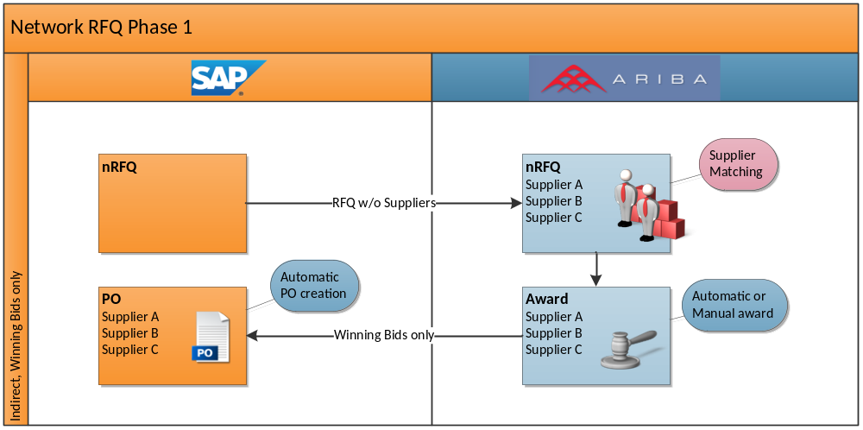
Scope of this FRD

    - Goals
Support the following use case:
- Network RFQ, initiated through SAP ERP
  - Create RFQ in ERP
  - Transfer to Ariba
  - Determine bidders in Ariba through private or public matching
  - Utilize AN for RFQ management and award
  - Send back individual supplier awards to ERP with immediate creation of Purchase Orders

The Steps in Bold are subject of this FRD.

    - Non-Goals
- Network Vendor Master Integration. This is described in “AS-1001_SE_for_NetworkEnabled_RFQs”.
- Ariba Network RFQ response is described in “CI-202 Support Network RFQ Quote Document on SAP ERP Adapter”

  - High Level Requirements
    - Support the RFQ Document Creation
ERP Configuration and enhancement
- RFQ Document Type customizing
- Dummy Supplier creation
- ALE/IDOC configuration and output determination to send message to PI
- BADI implementation for validity checks – e.g. disallow subsequent changes

    - Support the RFQ Document Transfer to Ariba
- PI Integration Scenario Configuration
- Mapping
  - Control Data (Supplier Invite Types)
  - Header Data
  - Supplier Data
  - Line Item Data
- Transformation to cXML
- Send to Ariba Network

  - Dependencies
This solution is dependent on the implementation of the nRFQ feature in 13s1 and . It may also depend on 13s3.
The solutions that are made shall be consistent with SAP Business Suite
  - Business Impact Summary
End User Analysis - Impacted Personas  (For features requiring Design Exploration only. work with UCDG to fill in this section)  See P4 //ariba/devweb/ProductManagement/PMO/40 Operations/Projects/0008-Personas/PERSONAS/Personas_Summary_Listing.xlsx or via URL Access>:  <What business users (persona) will you be serving by solving this problem (can be Ariba) –describe details under 1 Functional Use Cases  And Use Case list only with end user goal and metrics to verify the success of each> | Not Applicable
End User Validation Plan
Revenue  <Provide annual estimates if possible> | Add reference to approved number if available
Reduction in Cost
<Provide annual estimate if possible in man weeks>
Customer Satisfaction Impact
<# of customer, key customers, buyers/suppliers, prospects/existing etc. >
User Impact/ User Change Management
<End user perspective>
Data Import/ Export & ERP Integration  <Identify any ERP / data integration requirements. Feature MUST support backward compatibility.> | Yes. This FRD is for this purpose.
Security requirements  <PII data, PKI data, regional constrains, …data archive and purge> | None
Reporting  <Identity any significant reporting implications, either to existing reports or need for new reports> | None
Product Packaging  <Packaging ramifications, both to related solutions and by role access> | Available to All Levels of AN and Ariba Sourcing
Performance and Capacity Guidelines  <Attributes e.g., expected user response times, capacity ranges> | None
Competition  <Impact feature will have on competition, which competitors have this feature?> | Currently, none of our competitors have the ability to do nRFQ and link with an Oracle ERP
Others
<Add any other info that capture the business impact of the feature>

  - Customer Validation Strategy
<Identify key collaborators, domain experts, early adopters for this feature. Identify the customer(s) that will be asked to validate the requirements, the forum for gathering feedback, and if appropriate, the time in the release cycle that a customer demo will be provided to confirm requirements are met. This will not apply for all features. If it does apply, this validation should be tracked as a milestone exit criteria for this feature.>

  - Readiness Considerations
None

  - Other Considerations
Globalization/Localization | None
Documentation | All of the Integration Documentation for Oracle and Network will need to be updated.
Training | None
Support | None
Deployment | None
Pricing/ Costing | None
SPD (new or changes) | None

  - Definitions
Network RFQ: A Request for Quote, which is sent from the Buyer’s ERP, with a fast turnaround in mind. This is like a pre-Purchase order, where the buyer can verify the price, quantity, shipping and tax before placing an order.
Request Document: A part of the nRFQ that comes from the Buyer. It contains the commodity, supplier ship to, and description of the nRFQ (see all fields in CXML tables in Appendix)
Quote Document: A part of the nRFQ that comes from the Supplier as a response to the buyer. It contains pricing, tax, shipping and quantity information. (see all fields in CXML tables in Appendix)

- Detailed Functional Requirements
  - Business Requirements
See Master FRD.

End-To-End Process assumptions:
- User creates an RFQ document in SAP ERP
  - from scratch
  - with reference to one or multiple purchase requisitions
  - with reference to an existing ERP contract
- User creates one RFQ document with a maximum number of one specific supplier
- User will not use a collective RFQ number
- User selects matching option private or public through the selection of RFQ document type
- Once an RFQ is sent to Ariba, it will be locked for subsequent changes (13s1 supports this so we should support this unless its too hard to do in ERP. Restriction is to do this before RFQ closes)
- The Ariba RFQ ID will not be visible in ERP RFQ.
- The subsequent RFQ management will entirely take place in Ariba.
- There is no backward channel into ERP to update the ERP RFQ at any point of time.
- In general, Suppliers are known in ERP before an award would be sent back. If a new supplier from public matching would be awarded, the supplier data can also be included in the cXML. The supplier would be created as an ERP one-time supplier in that case. (still need to confirm).
- Purchase Order will be created with organizational data from ERP RFQ and with reference to Purchase Requisitions if supplied. Document IDs need to be sent in the message.

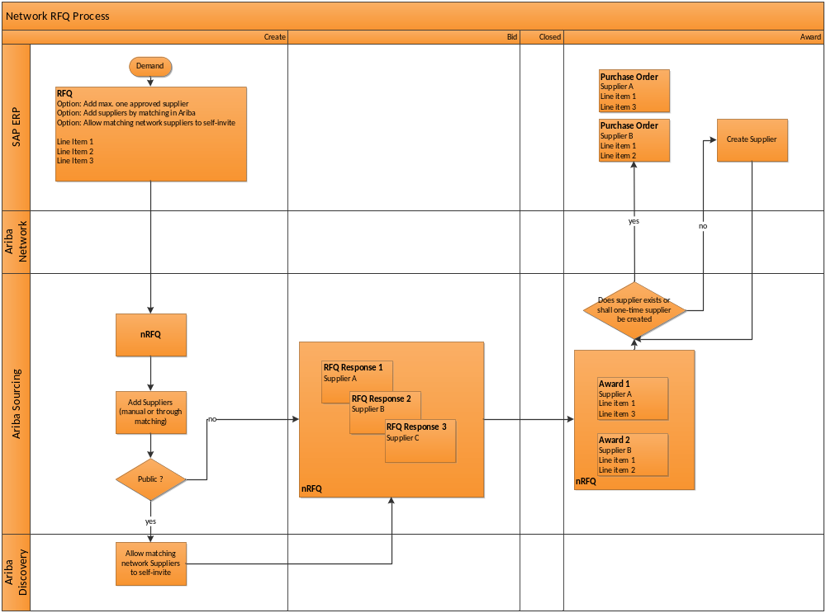

Scope of this FRD
  - Risk Analysis and mitigation

  - Impacted solutions
<Check impacted solutions and highlight cross-dependencies>
Product | Impact  (yes) | Impacts by customer segments | Highlight  Cross-dependencies
Ariba data Enrichment (ADE)
Spend Vis Pro
Spend Vis Basic
Sourcing Pro | Yes
Sourcing Basic | Yes
Start Sourcing | Yes
SIM
SIPM
Contract Pro
Contract Basic
Start Contracts
Analysis
P2P
P2O
Procurement Content
Services Procurement
Invoicing Pro
Payment Pro
Discount Pro
PO Automation
Invoice Automation
Ariba Network Adapter for Oracle
(Oracle Fusion Middleware)
Ariba Network Adapter for SAP
(SAP NetWeaver)
Ariba Network Transport Adapter
Travel & Expense
Ariba Network
Ariba Discovery
Quadrem
bProcess

  - Integration
  - Security requirements
Has your solution added any features that either: | yes/ no, if yes, please provide detail
Started collecting additional Personally Identifiable Information (PII) | No
Used solution-collected PII in any _new_ marketing activities | No
Added a new sub-processors of PII | No
Started providing more PII information to existing sub-processors | No

  - Reporting Impact
    - Customer Facing Reporting Impact
The reporting information will come from the solutions (Network, Sourcing) not from the Adapter.
      - What overall reporting changes are being requested?

      - What is the business purpose for the requested changes?

      - What do they hope to accomplish with these changes?

      - Are new or changed adoption reports needed?

    - Internal Ariba Reports like 580 or other reports

  - Product Packaging and Limited Entitlements
None
  - Performance and Capacity Guidelines
  - Special Readiness Issues

In product messaging?  <pop ups, splash pages> | No
3rd Party Impact | No
Supplier special communication/ Training | No
Buyer Special communication/ Training | Yes
Internal Special communication/ Training | No

  - Ariba Support Requirements
None

  - Site Reliability Engineering Requirements
The customer should be notified when a nRFQ fails to load from ERP or there is an error when the RFQ Document is pushed back from AN.
  - Personas

Bob the Buyer
//ariba/devweb/ProductManagement/PMO/40 Operations/Projects/0008-Personas/PERSONAS/Persona_Buyer_Bob(buyer).docx

Enablement Nina
//ariba/devweb/ProductManagement/PMO/40 Operations/Projects/0008-Personas/PERSONAS/Persona_Enablement_Nina.docx

  - Persona Information

- Use Cases
There are xx use cases
  - Functional Use Cases
<In the voice of the anticipated persona, describe the business problem and process steps you expect this feature to support. If there are multiple persona in the process flow, define each and highlight their unique needs and issues. Also consider the fact that a technical admin might not know the business process and who has what rights/access.
Include use cases for the following areas (either embedded or as a separate case):
Reporting
Support Related
Site Reliability Engineering use cases
Deployment
Performance and Capacity Guidelines <Attributes e.g., expected user response times, capacity ranges>
Point out if features are mainly build to “demo” to the economic buyer (the person to whom the product would be sold)>
    - Network RFQ, initiated through ERP – utilize AN for Supplier Matching and Awarding

The Buyer (Bill), manages an Network RFQ that he initiates in his SAP ERP System. He utilizes Ariba Network Features for the subsequent management of the Network RFQ, including determination of participating Suppliers.
The System, manages the transfer of messages from SAP ERP to Ariba and back.
Persona: Bob Buyer, The System

ID | Detailed Use Case (steps) | Expected Results | Priority
1 | Create RFQ  Bill wants to run a Network RFQ event and utilize the enhanced RFQ management options that the Ariba system offers.  He wants to invite suppliers that he has dealt with before, but also wants to allow new suppliers, that he has not dealt with before, to register for the event and send quotes.  Bill could use an existing contract as template for the RFQ event.  He could also create the RFQ from scratch and specify line items manually, or copy them from one or more Purchase Requisitions. | Bill expects that the ERP RFQ will be transferred to Ariba and the Ariba Network will automatically invite the known Suppliers based on the relevant Material Groups in his RFQ.  He also expects that potential Suppliers that are registered in the Ariba Network will be able to see his RFQ and register for it.  Bill will not expect to receive Quotations in SAP ERP.  Instead, he will expect to utilize RFx comparison and awarding tools in Ariba.  He expects that any of his awards will create Purchase orders in his ERP. (MUST)  Alternatively, he can also create Outline Agreements or update Purchasing Info Records. (not in CI-2) | Must
1.1 | Bill starts in ERP with the entry screen to ‘Create RFQ’.  He will select an RFQ Type which indicates that the Ariba Network process will run.  Bill can select from the following RFQ types:  Ariba Network No Matching  Ariba Network Private Matching  Ariba Network Public Matching  He decides to use the Public Matching Option.  He enters other required data like Quotation Deadline and Organizational Data. | The RFQ Type will be controlling a parameter in the Ariba Network RFQ that controls the Supplier Invite Options.  Private: Ariba will invite suppliers by line item commodity  Public. Invite suppliers by line item commodity and allow suppliers from the Network to self-invite. | Must
1.2 | On the item overview screen, Bill enters line item data with Material, quantity etc. |  | Must
1.3 | On the header view, Bill enters a start date. |  | Must
1.4. | On the Vendor Address View, Bill enters the number of a dummy supplier.  He could also use the number of a real supplier record.  Bill hits ‘Save’.  He will see the RFQ document number and note it down. | The System will save the RFQ and run the message determination procedure and determine that this RFQ shall be processes through the Ariba Network. | Must
1.8. | The message that SAP ERP sends to Ariba controls that additional suppliers will be invited in Ariba, based on the RFQ document type ID. | Ariba will invite suppliers by line item commodity and allow suppliers from the Network to self-invite. | Must
1.9 | The message that is sent to Ariba does not contain the dummy supplier data. | Dummy Supplier removed from the message to Ariba.
1.10 | If Bill uses a real supplier instead of a dummy supplier, the message that is sent to Ariba will contain this Supplier information. | Real Supplier contained in the message to Ariba.

2 | Change RFQ  Bob is not able to change an RFQ that has once been transferred to the Network | SAP ERP prevents the user from changing an RFQ once it has been transmitted to the Ariba Network | Must

- Feature Requirements
  - SAP ERP - Configuration to Support Business Process
- Create Dummy Supplier
- Create RFQ Document Types
- Setup ALE/IDOC configuration
- Setup Message Control
- BADI implementation for validity checks – e.g. disallow subsequent changes
  - SAP PI - Send RFQ Documents from ERP
RFQ is initiated from SAP ERP and sent to the network through PI.
The Adapter will Extract the ERP data, transform it to CXML and load it on to the Ariba Network. The Ariba network will route the Request Document to Ariba Sourcing. A sourcing RFQ event will be created automatically and linked to the nRFQ via Ariba Network.

The adapter should check to see if this sourcing event is created and provide an error notification if the process fails. The error notification should be written by the documentation team and use non-technical language.

Key information that must be contained in the message:

ERP Name |  | Description | Comment
Header | RFQ ID | This is the unique ID in ERP for the RFQ
Header | Document Type | Used to control Supplier Invitation Type | Map to “MatchingType”
Header | Purchasing Organization | Not supporter in cXML | Being checked
Header | Purchasing Group | Not supporter in cXML | Being checked
Header | Company Code | Not supporter in cXML | Being checked
Header | Inco Term | Not supporter in cXML | Being checked
Header | Payment Term | TODO: Find what Quadrem does for this?
Header | Validity Start | Start of the period in which the quotation is to be submitted
Header | Quotation Deadline | Deadline for Submission of Bid/Quotation
Header | Apply By | Date by which the bidder must have indicated his willingness to submit a quotation (bid).
Ship To |  | Address Details for Ship-To Location
Supplier | ID | ERP Vendor ID | Mapped only if Vendor is not the “Dummy” Vendor
Supplier | Name |  | Needed for Supplier Quick Enablement “On the Fly”
Supplier | Email
Line Item | Item Number
Line item | Item Category
Line item | Material Code
Line item | Item Description
Line item | Quantity
Line item | Unit or measure
Line item | Material Group
Line item | Plant
Line item | Delivery Date

Details with IDOC Field Names:
ERP Field Label | Segment | Field | Required
RFQ | E1EDK01 | BELNR | Yes
Purchasing Organization | E1EDK14 | ORGID | Yes
Purchasing Group | E1EDK14 | ORGID | Yes
Company Code | E1EDK14 | ORGID | Yes
Currency | E1EDK01 | HWAER | Yes
Validity Start Date | E1EDK03 | DATUM | Yes
Quotation Deadline Date | E1EDK03 | DATUM | Yes
Item Category | E1EDP01 | PSTYP | Yes
Material | E1EDP19 | IDTNR | Yes
Short Text | E1EDP19 | KTEXT | Yes
 | E1EDC01 | KTXT1 | Yes
Material Group | E1EDP01  E1EDC01 | MATKL | Yes
RFQ Quantity | E1EDP01 | MENGE | Yes
Order Unit | E1EDP01 | MENEE | Yes
Plant | E1EDP01 | WERKS | Yes
Delivery Date | E1EDP20 | EDATU | Yes
Item Text |  |  | Yes
Item Long Description |  |  | Yes
Delivery Address |  |  | Yes

  - Other Considerations/Requirements

Performance Metrics:
Adoption of this feature will be driven by adoption of the nRFQ feature and the Adapter.

Globalization Impact (currency, translation, etc.):
Currency mapping and behavior should work exactly like they do on an Ariba Purchase Order Document.

Translation behavior should not change from the current ERP to AN processes that exist (Purchase Order etc)

Migration Impact:
None

Architecture Impact:
Administration Impact:
None
Customizations expected:
TBD

- User Impact and Change Management
None, this is not an end user feature.Appendix
- CXML format for nRFQ

//ariba/devweb/ASM_Suite/versions/Integration Fast Trains/FRD/SampleCXMLs.zip

